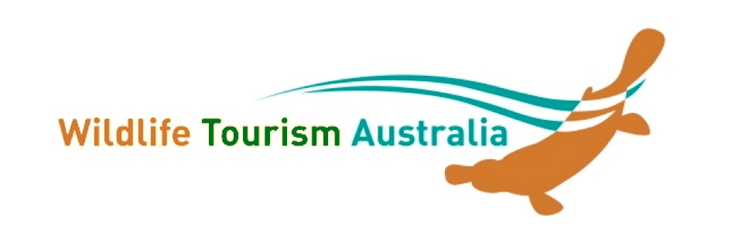
NEW MEMBER APPLICATION

Applicant Details
Name/Contact name: ____________________________________ Date _________________
Business/Organisation/Institution (if applicable): ______________________________________
Postal Address: _______________________________________________________________
Suburb: _____________________________________ State: _______ Postcode: _______
Phone: _______________________ Mobile __________________ Fax: ________________
Email: _________________________Website: (if app) ________________________________

What is your interest in wildlife tourism?

What is your involvement in environmental sustainability?

What is your involvement in quality wildlife education/interpretation?

Membership Type: Please tick the category you wish to join

❑ Larger business or NGO * $120
❑ Small NGO (<10 fulltime employees) or business (<5 fulltime employees) * $80
❑ Individual # $50
❑ Student/Concession # (as per website) please provide concession identification $25

* includes a promotional page on the WTA website # includes paragraph on your background and interests
All members are entitled to benefits as outlined on the WTA website.

All fees are in Australian Dollars ($AUD) and GST is NOT Applicable. Do NOT pay until approved

Please email this form to the WTA Committee - membership@wildlifetourismaustralia.org.au
or post to Wildlife Tourism Australia c/- Rebecca Scollen, University of Southern Queensland, West Street, Toowoomba, QLD, 4350.

Thank you! Your application will be circulated to the committee and you will be notified within 14 days.

PLEASE NOTE: Membership is from 1st July to 30th June the following year.

