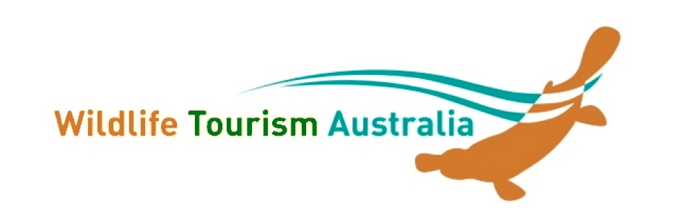
NEW MEMBER APPLICATION

Applicant Details
Name/Contact name: ____________________________________ Date _________________
Business/Organisation/Institution (if applicable):____________________________________
Postal Address:_________________________________________________________
Suburb: _____________________________________ State: _______ Postcode: _______
Phone: _________________ Mobile ______________ Fax: ________________
Email: _________________________Website: (if app) ________________________________

What is your interest in wildlife tourism?

What is your involvement in environmental sustainability?

What is your involvement in quality wildlife education/interpretation?

Membership Type: Please tick the category you wish to join

❑ Larger business or NGO * $120
❑ Small NGO (<10 fulltime employees) or business (<5 fulltime employees) * $80
❑ Individual # $50
❑ Student/Concession # (as per website) please provide concession identification $25

* includes a promotional page on the WTA website # includes paragraph on your background and interests
All members are entitled to benefits as outlined on the WTA website.

All fees are in Australian Dollars ($AUD) and GST is NOT Applicable. Do NOT pay until approved

Please email this form to the WTA Membership Secretary, Dr Simin Maleknia - Simin.Maleknia@uts.edu.au
or post to Wildlife Tourism Australia c/- Dr Ronda Green, 1770 Running Creek Road, Rathdowney, Qld 4287

Thank you! Your application will be circulated to the committee and you will be notified within 14 days.

PLEASE NOTE: Membership is from 1st July to 30th June the following year.

