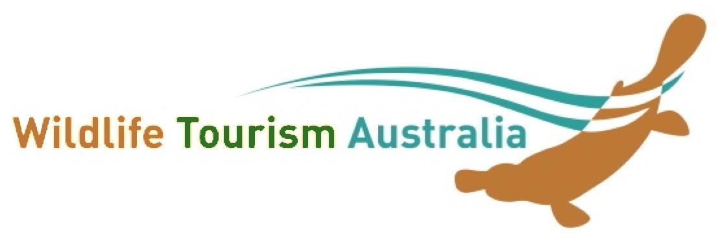

MEMBERSHIP INVOICE
Wildlife Tourism Australia Inc.
ABN 27 397 929 926

Please tick: [ ] NEW [ ] RENEWAL

Member Details - Date / /
Name
Business/Organisation/Institution:
Postal Address:
Website: Main contact email:
Invoice contact [if different] Name: Email:

Membership Type: All fees are in Australian Dollars ($AUD) and GST is NOT applicable

[ ] Large Corporate/NGO $120 [ ] Small NGO <10 or business <5 f/t employees $80

[ ] Individual $50 [ ] Student/Concession $25

Payment Details: Please place an ‘X’ next to the payment option you select

[ ] Bank Transfer - Bank of Queensland
Account Name: Wildlife Tourism Australia BSB:124001 Acc No. 22160306
NB: Please provide a description (e.g. your name or business, abbreviated if necessary) when depositing so we know who it’s from

[ ] Cheque / Money Order: (Please make payable to Wildlife Tourism Australia Inc.)
Please post payment with this form to Wildlife Tourism Australia, c/- Dr Ronda Green, WTA, 1770 Running Creek Rd., Rathdowney Qld 4287.

Please also advise Elleke Leurs (membership secretary) at Elleke.Leurs@utas.edu.au when you have done so, and cc to chair@wildlifetourismaustralia.org.au .

Corporate/NGO members only. Do you wish to add/edit a promotional page? YES/NO
please send a couple of paragraphs of text, 2 or 3 photos, your logo, other logos you'd like included (e.g. eco-certification) all jpgs preferably <1mb, website and contact details to Ronda Green at chair@wildlifetourismaustralia.org.au
Individual members. Would you like a paragraph on your (wildlife and/or tourism related) work/study interests on the website (please attach copy or send to webmaster) YES/NO

Names and emails of any others within the member operation/organisation who would like to receive our newsletter

……………………….…..............................................................................................…
..............................................................................................…………………………………….

