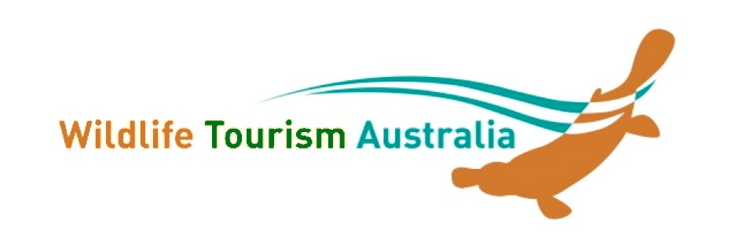
NEW MEMBER APPLICATION
Wildlfie Tourism Australia Inc.

Applicant Details
Name/Contact name: ____________________________________ Date _________________
Business/Organisation/Institution (if applicable):____________________________________
Postal Address:_________________________________________________________
_________________________________________________ Postcode: _______
Phone: _________________ Mobile ______________ Fax: ________________
Email: _________________________Website: (if app) ________________________________

What is your interest in wildlife tourism?

What is your involvement in environmental sustainability?

What is your involvement in quality wildlife education/interpretation?

Membership Type: Please tick the category you wish to join

❑ Larger business or NGO * $120
❑ Small NGO (<10 fulltime employees) or business (<5 fulltime employees) * $80
❑ Individual # $50
❑ Student/Concession # (as per website) please provide concession identification $25

* includes a promotional page on the WTA website # includes paragraph on your background and interests. Please provide this once accepted. All members are entitled to benefits as outlined on the WTA website.

All fees are in Australian Dollars ($AUD) and GST is NOT Applicable. Do NOT pay until approved

Please email this form to the WTA Membership Secretary, Darren Green darren.platypuscorner@bigpond.com
or post to Wildlife Tourism Australia, 1770 Running Creek Road, Rathdowney, Qld 4287

Thank you! Your application will be circulated to the committee and you will be notified within 14 days.

PLEASE NOTE:
Membership is from 1st July to 30th June the following year.
We are very aware of the hardships due to Covid-19. If you wish to join but are suffering financial hardship please contact us and explain darren.platypuscorner@bigpond.com

