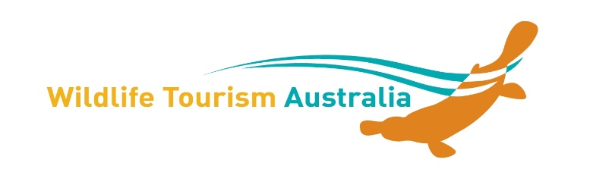

Exhibitor Trade Display Application

Wildlife Tourism Conference Geelong - 30 September to 2 October 2015

Wildlife Tourism Australia is keen to support the local wildlife tourism community.

We have a limited number of low cost exhibitor/trade display opportunities for your wildlife, birding or whale-watching tours etc, eco-lodge, zoo, government department, wildlife association or anything else of relevance you would like to promote during the conference.

- $80 per day or $200 for 3 days for commercial enterprises
- $30 per day or $80 for 3 days for non-profit organisations
Amounts are in Australian Dollars and do not include GST

Exhibitors will
- Have 1 trestle table and 1 chair and enough room for a pullup banner or brochure stand (Please ensure that you bring your own table cloths, power boards/leads etc. if needed)
- Receive one exhibitor badge – note this does not provide access to any conference sessions, lunch, morning and afternoon teas.
Please complete this form and return to Caz by email at events@wildlifetourism.org.au as soon as possible. We will be in contact with you and provide you with the details for payment by bank transfer if we can confirm space is available for you.

Name of Business or Group ……………………………………………………………
Commercial business Non-Profit
Address ………………………………………………………………………….…..………
………………………………………………………………………………………………….
Contact Name* for all information …………………………………….……………
Name of person staffing stand ……………………………………………………….
(If role is being shared – please provide us with all names and preferably times).
Description of what will be on display/for sale ………………………………………
………………………………………………………………………………………………….
Do you need access to Power: Yes ____ No____ (please tick – limited spaces)

This is a “Green Conference” - so WTA requires ALL exhibitors to comply with this – including no disposable packaging particularly bottled water, minimum printed material and waste, use of recycled products as well as maintaining a clean area, using recycling bins, and removing all materials and rubbish from the area.
Wildlife Tourism Australia and the organising committee do not accept any liability for losses incurred in the event of the conference being cancelled or postponed due to an unforeseen event or any other event that renders performance of this conference inadvisable, illegal, impracticable or impossible.
The exhibition floor plan will be subject to change without notice and positioning will be at the discretion of the organising committee.
No valuable items should be left unattended at your stand at any time and especially not overnight. No responsibility is accepted for any loss or damage to equipment and display materials
Exhibitor spaces are limited so cancellation of a booking must be advised by email. Cancellations within 7 working days of the conference will receive no refund. Cancellations received 7 - 30 days prior to the Conference will receive a refund of any payments less 50% deposit. Full refund may be provided if the space can be sold to another exhibitor.
Anyone wishing to attend the visit or attend the conference [including meals] must register as a day or full delegate before the conference.
Signs and Banners - No signs or banners may be affixed to the venue and should be free standing, pop-up banners to allow for easy placement.
Damage to the Venue - The cost to repair any damage to the venue deemed to have been caused by your staff, contractors, agents or guests will be the sole responsibility of your organisation.
Storage - There is limited storage on site for exhibition equipment or packaging.
Insurance - All exhibitors should have public liability insurance for the period of the exhibition. The conference will not be responsible for any loss or injury that may occur to the exhibitor, exhibitor’s employees registrants, the public or property from any cause whatsoever prior to, during and the subsequent period of the meeting. Exhibitors shall indemnify and hold harmless WTA from all liability (damage or accident) that might ensue from any cause resulting to or connected with the transportation, placing, removal or display of exhibits.

I agree to the terms and conditions as set out above:

Contact Name* _____________________________________________________
Signed______________________________ Dated:______________________
Email :______________________________Mobile Phone: __________________

